Multiple-choice section

|  |  |  |  |  |  |  |  |  |  |  |
| --- | --- | --- | --- | --- | --- | --- | --- | --- | --- | --- |
| Question | 1 | 2 | 3 | 4 | 5 | 6 | 7 | 8 | 9 | 10 |
| Answer | A | D | C | B | D | D | B | A | D | A |

Question 1 [3.1]

A



Question 2 [3.1]

D



Question 3 [3.1]

C



Question 4 [3.1]

B



Question 5 [3.2]

D



Question 6 [3.4]

D



The dilation factor is 8, the coefficient of x2.

Question 7 [3.4]

B



y1 has been reflected in the x-axis, dilated by 4 and moved 3 down. It has not been translated any further to the right.

Question 8 [3.5]

A

x2 – 11x + 24  
-3 × -8 = 24 and -3 – 8 = -11

x2 – 11x + 24 = (x – 3)(x – 8)

Question 9 [3.6]

D

x2 + 6x + 9  
3 × 3 = 9 and 3 + 3 = 6

So, x2 + 6x + 9 = (x + 3)2

Question 10 [3.7]

A



Multiple-choice total marks: 10

Short answer section

Question 11 2 marks [3.5]

(a) Factorising involves taking out the highest common factor of terms.

(b) x2 – x – 36 is an example of a monic quadratic.

Question 12 2 marks [3.6]

A perfect square is an expression of the form , which expands to .

|  |  |  |
| --- | --- | --- |
| For , | For : |  |

Question 13 3 marks [3.1]



Question 14 3 marks [3.2]



Question 15 3 marks [3.4]



-3 is a dilation factor of 3 and a reflection in the x-axis

x + 5 is a horizontal translation of 5 units left

-1 is a vertical translation of 1 unit down.

Question 16 4 marks [3.4]

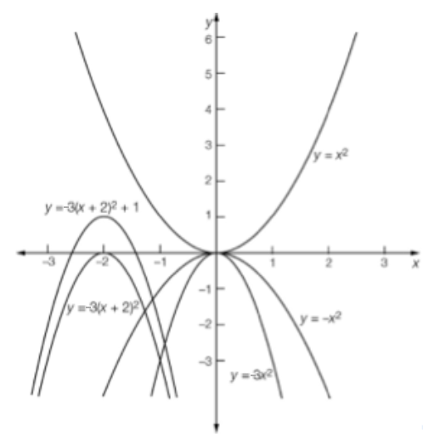

Question 17 3 marks [3.5]

|  |  |
| --- | --- |
| (a) x2 + 4x – 5  (b) 5 × -1 = -5 and 5 – 1 = 4 x2 + 4x – 5 = (x + 5)(x – 1) | (c) (x + 5)(x – 1) = (a + 2 + 5)(a + 2 – 1) = (a + 7)(a + 1) |

Question 18 3 marks [3.6]



Question 19 3 marks [3.6]

(a) Area of large square:   
Area of small square: 

(b) Shaded area: x2 – (x – 2a)2  
= [(x – (x – 2a)][x + (x – 2a)]  
= (2a)(2x – 2a)  
= 4a(x – a)

Question 20 3 marks [3.2, 3.6]



Question 21 3 marks [3.7]



Question 22 4 marks [3.7]



Short answer total marks: 36

Extended answer section

Question 23 4 marks [3.6]

(a)   


(b) 



Question 24 4 marks [3.5]

(a) For t = 0, h = 28  
The ball is initially 28 m above the ground.

(b) h = -t2 + 3t + 28  
= -(t + 4)(t – 7)  
For h = 0, t = -4 and 7   
t = -4 is not a positive time.  
So the ball reaches the ground after 7 seconds.

Question 25 6 marks [3.1, 3.2]

(a) 

(b) 

(c)   
   
When expanded both give the same expression for the shaded area.

Extended answer total marks: 14

TOTAL test marks: 60